Mihai Tuhari

[mihai-razvan.tuhari@s.unibuc.ro](mailto:mihai-razvan.tuhari@s.unibuc.ro)

<https://github.com/mihaituhari/>

**Grafica pe calculator**

Proiect 2 (3D)

*Realizati o scena 3D complexa.*

🌲🌲🌲🌲 🛣️ 🌕

## Implementare

Pentru o lectura mai coerenta si simpla asupra documentatiei de mai jos, incepem cu o captura de ecran a proiectului

.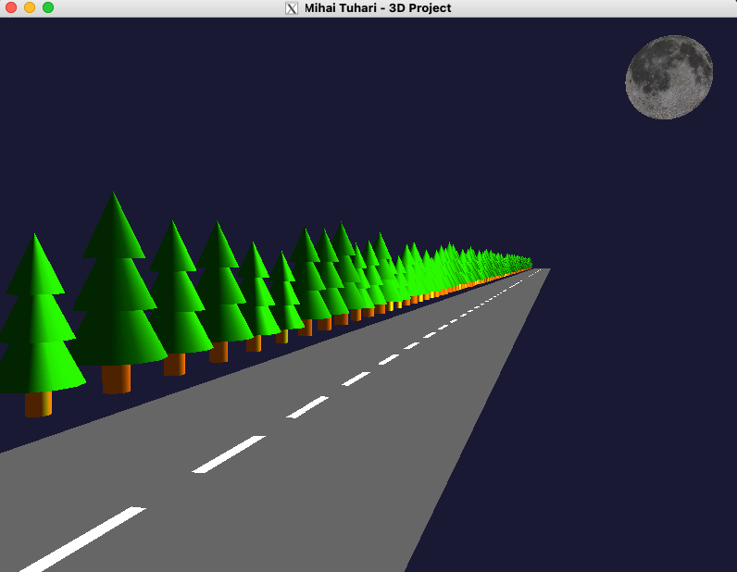

## 

## Introducere

Am realizat o simulare a unui drum in miscare. Soseaua are marcaj rutier pe mijloc, iar pe marginea drumului sunt copaci de diverse dimensiuni ce se misca cu aceeasi viteza.

Se mai poate distinge luna din coltul scenei.

Programul principal este in fisierul [proiect2.cpp](https://github.com/mihaituhari/fmi/blob/main/gc/proiect2/proiect2.cpp) si foloseste libraria STB pentru incarcarea texturii pentru luna.

## Specificatii scena

### Texturi

Pentru manipularea texturilor am ales STB in loc de SOIL pentru ca pe MacOS SOIL nu este compatibil.

Textura folosita pentru luna se regaseste in folderul [textures](https://github.com/mihaituhari/fmi/blob/main/gc/proiect2/textures):

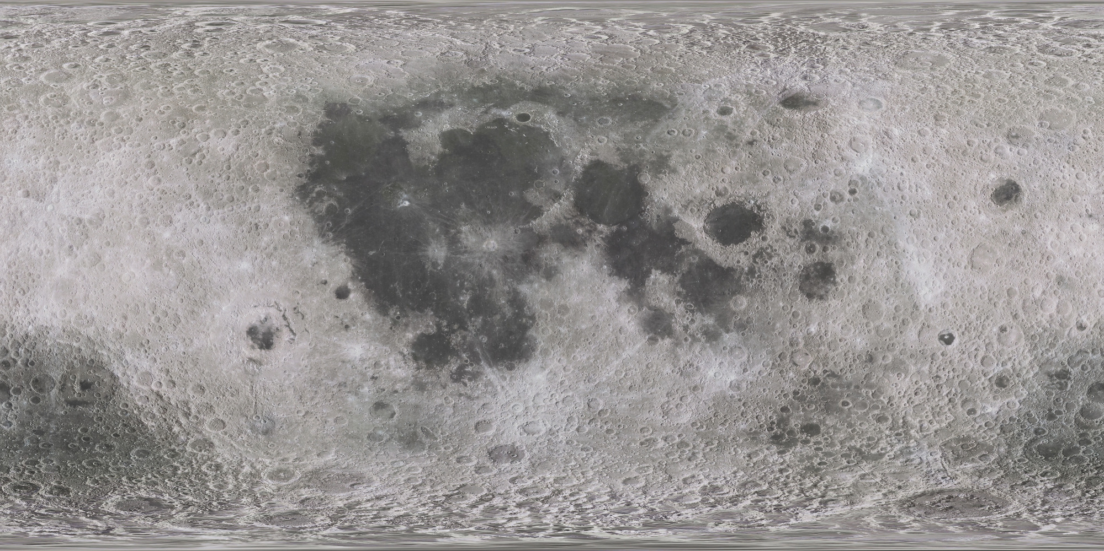

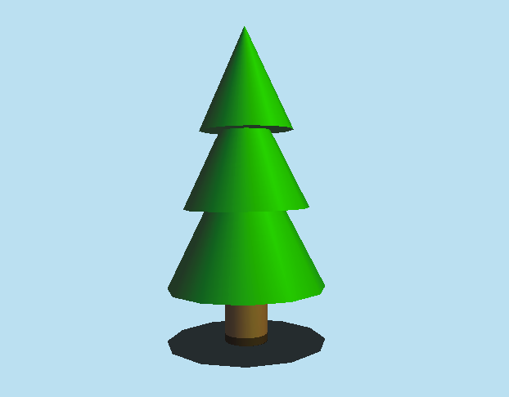

### Copacii

Brazii de pe marginea drumului sunt realizati fiecare din catre 3 conuri si un cilindru pentru trunchi. Pentru dinamism si originalitate, fiecare copac are aplicat un factor de scalare intre 0.8 si 1.2.

### Luna

Luna este o sfera cu o textura aplicata, impreuna cu setari pentru iluminare puternica.

### Marcajul rutier

Acesta este format din dreptunghiuri albe cu o anumita distanta intre ele.

### Animatie

Pentru a simula miscarea, am folosit o variabila roadOffset care se modifica la fiecare frame cu valoarea constantei ROAD_SPEED.

## Specificatii control si camera

### Control camera

Unghiul implicit este cel afisat in prima imagine.

Folositi sagetile si tastele + si - pentru a roti camera si a da zoom in/out.

Apasati tastele 1, 2, 3, 4 pentru a schimba intre camerele presetate.

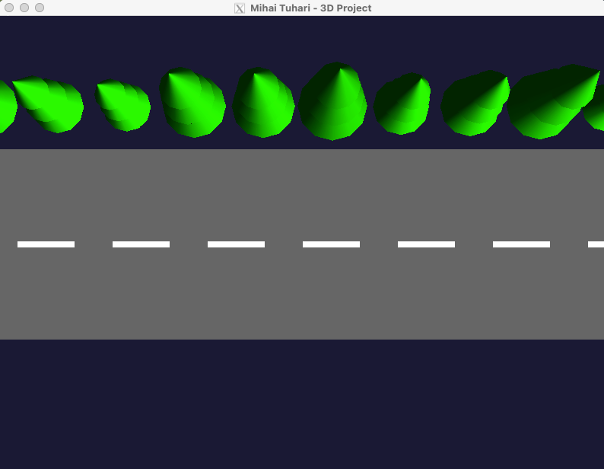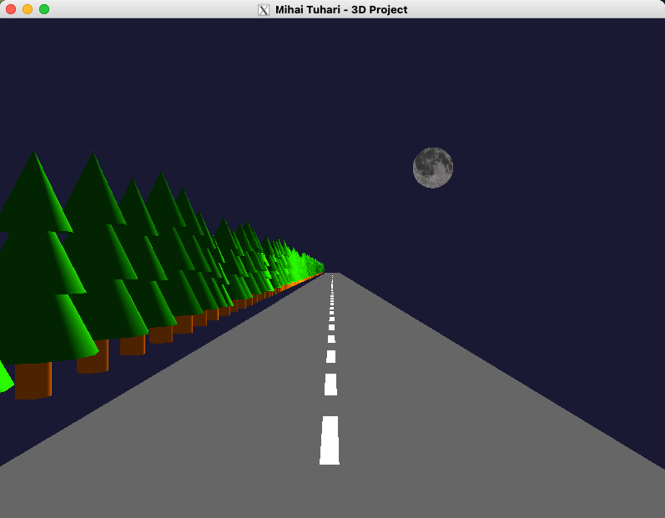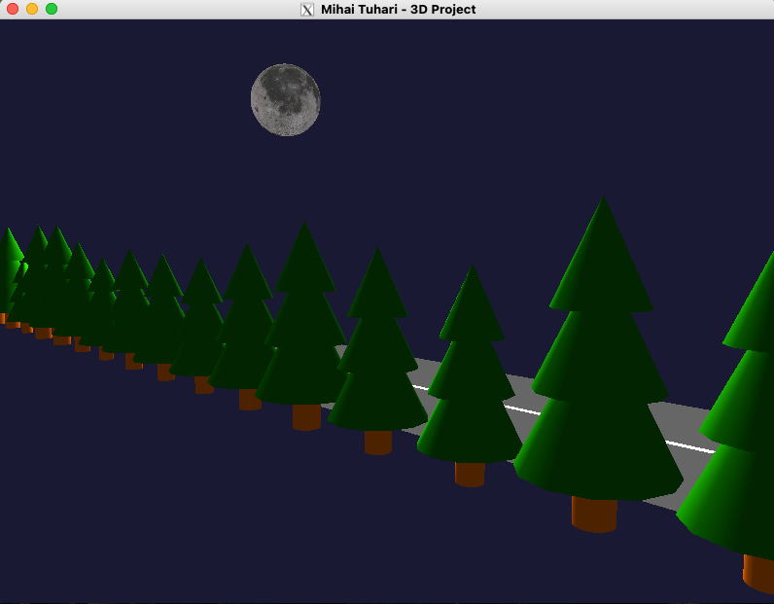

### Ceata

Apasati tasta F pentru a activa/dezactiva ceata. Ceata este randata de la inceput dar este dezactivata din flag-ul fog = false.

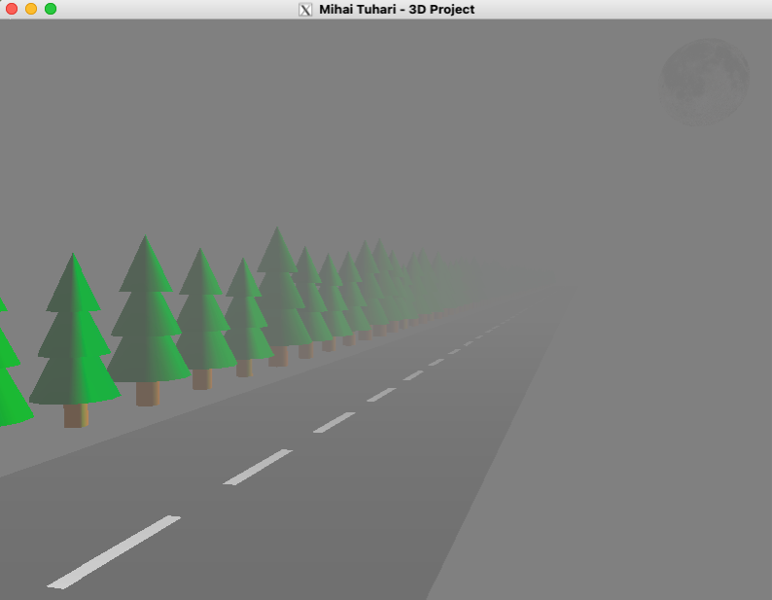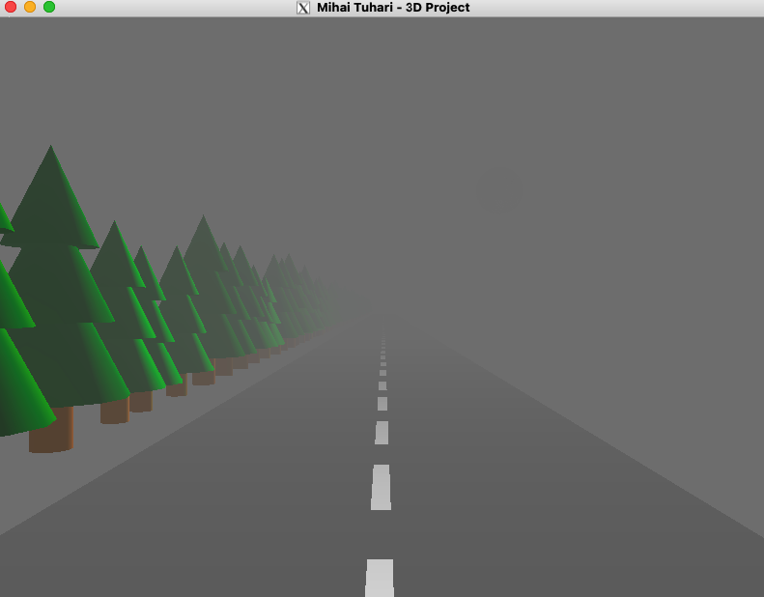

## **Aspecte tehnice**

### Design modular

Am abordat proiectul cu un design modular si am incercat sa folosesc cat mai multe functii pentru a separa logica.

### Configurabilitate

Animatia este usor configurabila din variabilele globale definite la inceputul fisierului [proiect2.cpp](https://github.com/mihaituhari/fmi/blob/main/gc/proiect1/proiect2.cpp).

Acolo regasiti variabile pentru:

* Camera implicita
* Ceata (flag)
* Dimensiune si viteza drum

### Limba

Intreg codul (cu tot cu comentarii), este scris in limba Engleza din motive de coerenta si simplitate, pentru a evita combinatia intre termeni in limba Romana si Engleza.

### Video

Puteti vedea unvideo cu animatia in actiune la sfarsitul paginii <https://github.com/mihaituhari/fmi/tree/main/gc/proiect2> ori direct [aici](https://github.com/user-attachments/assets/845725d7-fcbc-42aa-a73c-4dbae88b6a3f).

### Codul sursa

Este inclus pe paginile urmatoare, dar il puteti regasi si pe contul meu de GitHub la adresa:

<https://github.com/mihaituhari/fmi/tree/main/gc/proiect2>

| */\*\**  *\* Project 2 - 3D Scene*  *\**  *\* @author Mihai Tuhari*  *\* @date January 2025*  *\*/*  #define **STB_IMAGE_IMPLEMENTATION**  #include <iostream>  #include <GL/freeglut.h>  #include "libs/stb_image.h"  *// Camera position*  *float* Refx = 0.0f, Refy = 0.0f, Refz = 0.0f;  *float* alpha = 0.05f;  *float* beta = -1.3f;  *float* dist = 26.0f;  *float* Obsx, Obsy, Obsz;  *// Fog flag*  *bool* fog = *false*;  *// Road elements*  *float* roadOffset = 0.0f;  *const float* ROAD_SPEED = 0.1f;  *const float* ROAD_WIDTH = 10.0f;  *const float* ROAD_LENGTH = 800.0f;  *// Moon texture*  GLuint textureMoon;  *const* std::string texturePath = "/Volumes/mihai/dev/fmi/gc/proiect2/textures/";  *int* width, height, channels;  *struct* TreePosition {  *float* x, y, z;  *float* scaleFactor;  };  std::vector<TreePosition> treePositions;  *void* loadTexture(*const* std::string &path, GLuint &textureID) {  stbi_set_flip_vertically_on_load(1);  *unsigned char* *image = stbi_load(path.c_str(), &width, &height, &channels, STBI_rgb_alpha);  *if* (!image) {  std::cerr << "Failed to load texture: " << path << std::endl;  exit(1);  }  glGenTextures(1, &textureID);  glBindTexture(**GL_TEXTURE_2D**, textureID);  glTexParameteri(**GL_TEXTURE_2D**, **GL_TEXTURE_MIN_FILTER**, **GL_LINEAR**);  glTexParameteri(**GL_TEXTURE_2D**, **GL_TEXTURE_MAG_FILTER**, **GL_LINEAR**);  glTexParameteri(**GL_TEXTURE_2D**, **GL_TEXTURE_WRAP_S**, **GL_CLAMP_TO_EDGE**);  glTexParameteri(**GL_TEXTURE_2D**, **GL_TEXTURE_WRAP_T**, **GL_CLAMP_TO_EDGE**);  glTexImage2D(**GL_TEXTURE_2D**, 0, **GL_RGBA**, width, height, 0, **GL_RGBA**, **GL_UNSIGNED_BYTE**, image);  stbi_image_free(image);  }  *void* drawMoon() {  glEnable(**GL_TEXTURE_2D**);  glBindTexture(**GL_TEXTURE_2D**, textureMoon);  GLfloat moonAmbient[] = {1.0f, 1.0f, 1.0f, 1.0f}; *// Bright white*  GLfloat moonDiffuse[] = {1.5f, 1.5f, 1.5f, 1.0f}; *// Increased diffuse brightness*  GLfloat moonSpecular[] = {2.0f, 2.0f, 2.0f, 1.0f}; *// High specular reflection*  GLfloat moonShininess[] = {128.0f}; *// Very shiny surface*  glMaterialfv(**GL_FRONT**, **GL_AMBIENT**, moonAmbient);  glMaterialfv(**GL_FRONT**, **GL_DIFFUSE**, moonDiffuse);  glMaterialfv(**GL_FRONT**, **GL_SPECULAR**, moonSpecular);  glMaterialfv(**GL_FRONT**, **GL_SHININESS**, moonShininess);  glPushMatrix();  glTranslatef(15.0f, 30.0f, 15.0f);  GLUquadric *quad = gluNewQuadric();  gluQuadricTexture(quad, **GL_TRUE**);  gluSphere(quad, 3.0f, 30, 30);  gluDeleteQuadric(quad);  glPopMatrix();  glDisable(**GL_TEXTURE_2D**);  }  *void* initTreePositions() {  *float* spacing = 3.5f;  *int* numTrees = (*int*) (ROAD_LENGTH / spacing) + 1;  *for* (*int* i = 0; i < numTrees; i++) {  TreePosition tree;  tree.x = -ROAD_WIDTH / 2 - 2.0f; *// Middle of the road*  tree.y = i * spacing; *// Even spacing*  tree.z = 0.0f; *// Road level*  *// Random scale factor (e.g., between 0.8 and 1.2)*  tree.scaleFactor = 0.8f + *static_cast*<*float*>(rand()) / (*static_cast*<*float*>(RAND_MAX / 0.4f));  treePositions.push_back(tree);  }  }  *void* drawRoad() {  *// Road surface*  glDisable(**GL_LIGHTING**);  glPushMatrix();  *// Main road surface (gray)*  glColor3f(0.4f, 0.4f, 0.4f);  glBegin(**GL_QUADS**);  glVertex3f(-ROAD_WIDTH / 2, -ROAD_LENGTH / 2, -3.0f);  glVertex3f(ROAD_WIDTH / 2, -ROAD_LENGTH / 2, -3.0f);  glVertex3f(ROAD_WIDTH / 2, ROAD_LENGTH / 2, -3.0f);  glVertex3f(-ROAD_WIDTH / 2, ROAD_LENGTH / 2, -3.0f);  glEnd();  *// Road divider lines (white)*  glColor3f(1.0f, 1.0f, 1.0f);  *float* lineSpacing = 5.0f;  *float* offset = 0;  *for* (*float* z = -ROAD_LENGTH / 2; z < ROAD_LENGTH / 2; z += lineSpacing) {  *float* adjustedZ = z + roadOffset + offset;  *// Wrap if exceeding road*  *if* (adjustedZ > ROAD_LENGTH / 2) {  adjustedZ -= ROAD_LENGTH;  }  *if* (adjustedZ < -ROAD_LENGTH / 2) {  adjustedZ += ROAD_LENGTH;  }  glBegin(**GL_QUADS**);  glVertex3f(-0.15f, adjustedZ, -2.99f);  glVertex3f(0.15f, adjustedZ, -2.99f);  glVertex3f(0.15f, adjustedZ + 3.0f, -2.99f);  glVertex3f(-0.15f, adjustedZ + 3.0f, -2.99f);  glEnd();  }  glPopMatrix();  glEnable(**GL_LIGHTING**);  }  *void* drawTree(*float* scaleFactor) {  GLfloat tree_ambient[] = {0.0f, 0.2f, 0.0f, 1.0f};  GLfloat tree_diffuse[] = {0.0f, 0.6f, 0.0f, 1.0f};  GLfloat tree_specular[] = {0.0f, 0.1f, 0.0f, 1.0f};  GLfloat tree_shininess[] = {10.0f};  glMaterialfv(**GL_FRONT**, **GL_AMBIENT**, tree_ambient);  glMaterialfv(**GL_FRONT**, **GL_DIFFUSE**, tree_diffuse);  glMaterialfv(**GL_FRONT**, **GL_SPECULAR**, tree_specular);  glMaterialfv(**GL_FRONT**, **GL_SHININESS**, tree_shininess);  *float* baseOffset = -(1.0f - scaleFactor) * 3.0f;  glPushMatrix();  glTranslatef(0.0f, 0.0f, baseOffset);  glScalef(scaleFactor, scaleFactor, scaleFactor);  *// Bottom cone*  glPushMatrix();  glTranslatef(0.0f, 0.0f, -2.0f);  glutSolidCone(1.5, 3.0, 12, 20);  glPopMatrix();  *// Middle cone*  glPushMatrix();  glTranslatef(0.0f, 0.0f, -0.5f);  glutSolidCone(1.2, 2.5, 12, 20);  glPopMatrix();  *// Top cone*  glPushMatrix();  glTranslatef(0.0f, 0.0f, 1.0f);  glutSolidCone(0.9, 2.0, 12, 20);  glPopMatrix();  *// Trunk material*  GLfloat trunk_ambient[] = {0.4f, 0.2f, 0.0f, 1.0f};  GLfloat trunk_diffuse[] = {0.6f, 0.3f, 0.1f, 1.0f};  glMaterialfv(**GL_FRONT**, **GL_AMBIENT**, trunk_ambient);  glMaterialfv(**GL_FRONT**, **GL_DIFFUSE**, trunk_diffuse);  *// Draw trunk*  glPushMatrix();  glTranslatef(0.0f, 0.0f, -3.0f);  GLUquadricObj *cylinder = gluNewQuadric();  gluQuadricDrawStyle(cylinder, **GLU_FILL**);  gluCylinder(cylinder, 0.4f, 0.4f, 1.0f, 20, 20);  gluDeleteQuadric(cylinder);  glPopMatrix();  glPopMatrix();  }  *void* drawTrees() {  *for* (*const auto* &pos: treePositions) {  *for* (*int* set = -1; set <= 1; set++) {  *float* yOffset = pos.y + roadOffset + (set * ROAD_LENGTH);  *if* (yOffset >= -ROAD_LENGTH / 2 && yOffset <= ROAD_LENGTH * 0.5) {  glPushMatrix();  glTranslatef(pos.x, yOffset, pos.z);  drawTree(pos.scaleFactor);  glPopMatrix();  }  }  }  }  *void* reshapeAndProjection(*int* w, *int* h) {  *if* (h == 0) h = 1;  *float* ratio = (*float*) w / h;  glMatrixMode(**GL_PROJECTION**);  glLoadIdentity();  glViewport(0, 0, w, h);  gluPerspective(45.0f, ratio, 0.1f, 500.0f);  glMatrixMode(**GL_MODELVIEW**);  }  *void* setupLighting() {  glEnable(**GL_LIGHTING**);  glEnable(**GL_LIGHT1**);  GLfloat moonLightAmbient[] = {0.5f, 0.5f, 0.5f, 1.0f}; *// Stronger ambient light*  GLfloat moonLightDiffuse[] = {1.5f, 1.5f, 1.5f, 1.0f}; *// Intense diffuse light*  GLfloat moonLightSpecular[] = {2.0f, 2.0f, 2.0f, 1.0f}; *// Bright specular highlights*  GLfloat moonLightPosition[] = {15.0f, 30.0f, 15.0f, 1.0f}; *// Position near the moon*  glLightfv(**GL_LIGHT1**, **GL_AMBIENT**, moonLightAmbient);  glLightfv(**GL_LIGHT1**, **GL_DIFFUSE**, moonLightDiffuse);  glLightfv(**GL_LIGHT1**, **GL_SPECULAR**, moonLightSpecular);  glLightfv(**GL_LIGHT1**, **GL_POSITION**, moonLightPosition);  }  *void* setupFog() {  GLfloat fogColor[] = {0.5, 0.5, 0.5, 1.0}; *// Fog color: light gray*  glFogi(**GL_FOG_MODE**, **GL_EXP**);  glFogfv(**GL_FOG_COLOR**, fogColor);  glFogf(**GL_FOG_DENSITY**, 0.05f);  glHint(**GL_FOG_HINT**, **GL_NICEST**);  glFogf(**GL_FOG_START**, 10.0f);  glFogf(**GL_FOG_END**, 100.0f);  }  *void* display() {  glClear(**GL_COLOR_BUFFER_BIT** | **GL_DEPTH_BUFFER_BIT**);  Obsx = Refx + dist * cos(alpha) * cos(beta);  Obsy = Refy + dist * cos(alpha) * sin(beta);  Obsz = Refz + dist * sin(alpha);  glLoadIdentity();  gluLookAt(Obsx, Obsy, Obsz, Refx, Refy, Refz, 0.0f, 0.0f, 1.0f);  setupLighting();  setupFog();  drawRoad();  drawMoon();  drawTrees();  glutSwapBuffers();  }  *void* renderAmbient() {  *if* (fog) {  glEnable(**GL_FOG**);  glClearColor(0.5, 0.5, 0.5, 1.0); *// Fog color*  } *else* {  glDisable(**GL_FOG**);  glClearColor(0.1f, 0.1f, 0.2f, 1.0f); *// Dusk-like background color*  }  }  *void* update(*int* value) {  roadOffset -= ROAD_SPEED;  *if* (roadOffset < -ROAD_LENGTH) {  roadOffset += ROAD_LENGTH;  }  glutPostRedisplay();  glutTimerFunc(16, update, 0); *// ~60 FPS*  }  *void* processSpecialKeys(*int* key, *int* xx, *int* yy) {  *switch* (key) {  *case* **GLUT_KEY_LEFT**:  beta -= 0.05;  *break*;  *case* **GLUT_KEY_RIGHT**:  beta += 0.05;  *break*;  *case* **GLUT_KEY_UP**:  alpha += 0.05;  *break*;  *case* **GLUT_KEY_DOWN**:  alpha -= 0.05;  *break*;  }  glutPostRedisplay();  }  *void* processNormalKeys(*unsigned char* key, *int* x, *int* y) {  *switch* (key) {  *case* '+':  dist -= 0.5;  *break*;  *case* '-':  dist += 0.5;  *break*;  *case* 'f':  *case* 'F':  fog = !fog;  renderAmbient();  *break*;  *// Default camera*  *case* '1':  alpha = 0.05f;  beta = -1.3f;  dist = 26.0f;  *break*;  *// Top view camera*  *case* '2':  alpha = 1.57f;  beta = 0.0f;  dist = 26.0f;  *break*;  *// Front view camera*  *case* '3':  alpha = 0.0f;  beta = -1.57f;  dist = 60.0f;  *break*;  *// Behind trees camera*  *case* '4':  alpha = 0.1f;  beta = -2.3f;  dist = 30.0f;  *break*;  *case* 27:  exit(0);  *break*;  }  glutPostRedisplay();  }  *int* main(*int* argc, *char* **argv) {  glutInit(&argc, argv);  glutInitDisplayMode(**GLUT_DOUBLE** | **GLUT_RGB** | **GLUT_DEPTH**);  glutInitWindowSize(800, 600);  glutInitWindowPosition(100, 100);  glutCreateWindow("Mihai Tuhari - 3D Project");  initTreePositions();  loadTexture(texturePath + "moon.jpg", textureMoon);  glutReshapeFunc(reshapeAndProjection);  glutDisplayFunc(display);  glutSpecialFunc(processSpecialKeys);  glutKeyboardFunc(processNormalKeys);  glutTimerFunc(16, update, 0);  renderAmbient();  glEnable(**GL_DEPTH_TEST**);  glutMainLoop();  *return* 0;  } |
| --- |